Digital Design

CSCE 2114-L007

Blake Fasse

February 6, 2017

[bafasse@uark.edu](mailto:bafasse@uark.edu)

Introduction

This lab was about using various integrated chips to create circuits on the bread board. The chips used were the 7404, the 7408, and the 7432 which had inverters, AND gates, and OR gates, respectively. The 7404 will take in three inputs and give three outputs while the 7408 and 7432 will both take in two inputs and each give one output.

Design

The 7404 had six inverters on it but only three were used. Since the 7404 only contain inverters there was not much difficulty to this other than finding the right length of wire. Wires were connected from three switches to three of the inverters and then the outputs were connected to the LED so whenever the switch is on active low then the LED would display active high and vice versa. The 7408 and 7432 IC’s were a bit more difficult to set up because instead of just taking in one input and giving one output both IC’s took in two inputs and gave one output. In the case of the 7404, which uses AND gates, the LED would only display active high when both switches were active high and any other combination would result in the LED displaying active low. In the case of the 7432, which uses OR gates, the LED would only display active low when both switches were active low and was at active high for any other combination of inputs. Below is a picture of the set up with the 7432 IC. 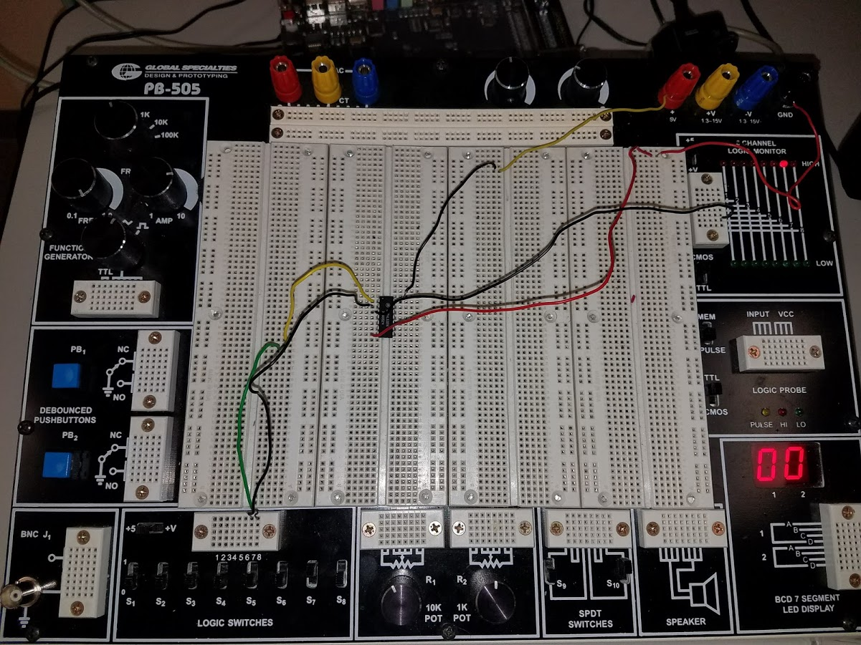

Results

The picture above shows the 7432 IC being implemented and the 7408 is very similar, if not identical, in the way it was implemented. As previously stated, the only way for the LED to be set to active low on the 7432 is when both switches are set to active low and any other input would result in the LED being set to active high. The exact opposite could be said of the 7408 in that the only way for the LED to be set to active low is when both inputs are active high. The 7404 also performed as expected by inverting every input.

Conclusion

The purpose of this lab was to test how different integrated circuits using the bread board. The lab required the use of three different IC’s, the 7404, the 7408, and the 7432. Both the 7408 and the 7432 were wired the same as shown in the picture above with both chips taking in two inputs and giving one output which showed how AND gates and OR gates worked. The 7404 has six inverters on it and three of them were used.